Requirements/Design Specification

**July2015 GH550**

**Existing customer (small container) formulas for service change guardrails are incorrect (CR 14080)**

Revision History

|  |  |  |  |
| --- | --- | --- | --- |
| **Date** | **Revision** | **Description** | **Author** |
| 5/18/2015 | 1.0 | Initial Version with Requirements | Gaurav Dawar |
|  |  |  |  |
|  |  |  |  |
|  |  |  |  |
|  |  |  |  |

The information furnished herein by Republic Services Inc. is proprietary and confidential to Republic Services Inc. personnel and is not to be duplicated, published, or disclosed to any third party in whole or in part without permission from Republic Services, Inc.

© Copyright 2012, Republic Services Inc. - All rights reserved.

Table of contents

1 Business Requirements 6

1.1 Purpose of the Design Specification 6

1.1.1 Bug list for current release 6

2 Competitor Overview and Assumptions 6

3 Design 6

4 Impacted Systems (InfoPro, TIBCO and BI) 8

5 Report Changes 8

6 Appendix 8

# Business Requirements

## Purpose of the Design Specification

This document highlights items to be fixed and implemented for the titled release.

### Bug list for current release

| GitHub Item  Number | **Description** |
| --- | --- |
| 550 | Existing customer (small container) formulas for service change guardrails are incorrect (CR 14080) |

# Overview and Assumptions

These formulas were implemented wrong from the implementation itself. Now these are fixed in R and the exact formula changes need to flow through Capture “Calculate guardrails” Util library function as well.

# Design

## #550 Existing customer (small container) formulas for service change guardrails are incorrect (CR 14080)

## Old incorrect R formulas

### Floor:

((cost_to_serve_month / (1 - curr_margin_percent + svc_base_marg_prem)) + apply(cbind(0,(((cost_to_serve_month / (1 - base_margin_new)) - (cost_to_serve_month / (1 - curr_margin_percent + svc_base_marg_prem))) * svc_gap_recovery_pct)),1,max))

### Avg:

((cost_to_serve_month / (1 - (curr_margin_percent + svc_targ_marg_prem))) +

apply(cbind(0,(((cost_to_serve_month / (1 - target_margin_new)) - (cost_to_serve_month / (1 - curr_margin_percent + svc_targ_marg_prem))) * svc_gap_recovery_pct)),1,max))

### Target:

((cost_to_serve_month / (1 - (curr_margin_percent + svc_str_marg_prem))) + apply(cbind(0,(((cost_to_serve_month / (1 - stretch_margin_new)) - (cost_to_serve_month / (1 - curr_margin_percent + svc_str_marg_prem))) * svc_gap_recovery_pct)),1,max))

## New Correct R formulas

### Floor:

((cost_to_serve_month / (1 - (curr_margin_percent + svc_base_marg_prem))) + apply(cbind(0,(((cost_to_serve_month / (1 - base_margin_new)) - (cost_to_serve_month / (1 - (curr_margin_percent + svc_base_marg_prem)))) * svc_gap_recovery_pct)),1,max))

### Avg:

((cost_to_serve_month / (1 - (curr_margin_percent + svc_targ_marg_prem))) +

apply(cbind(0,(((cost_to_serve_month / (1 - target_margin_new)) - (cost_to_serve_month / (1 - (curr_margin_percent + svc_targ_marg_prem)))) * svc_gap_recovery_pct)),1,max))

### Target:

((cost_to_serve_month / (1 - (curr_margin_percent + svc_str_marg_prem))) + apply(cbind(0,(((cost_to_serve_month / (1 - stretch_margin_new)) - (cost_to_serve_month / (1 - (curr_margin_percent + svc_str_marg_prem)))) * svc_gap_recovery_pct)),1,max))

## Capture Formulas

### Floor:

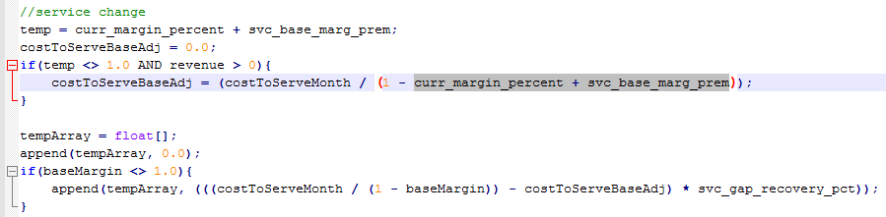

### Avg:

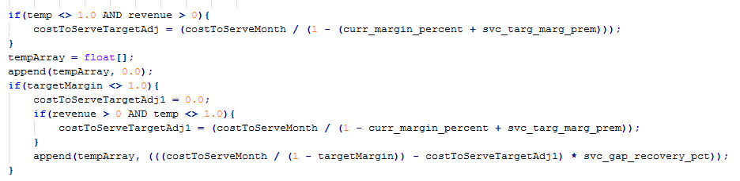

### Target:

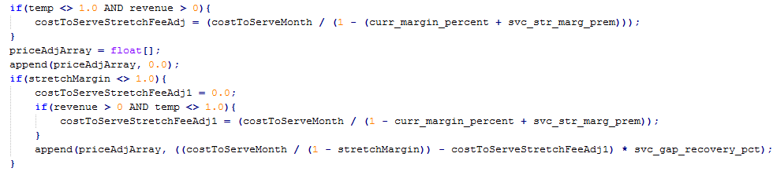

# Impacted Systems (InfoPro, TIBCO and BI)

No new variables, So it should not affect InfoPro AAE process.

# Report Changes

NA

# Appendix